**Pathways Intern: Jordan, Computer Science**

[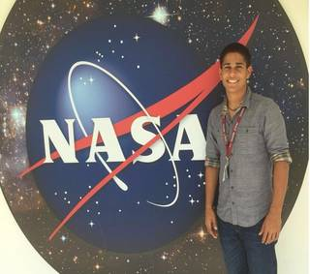](https://cms.nasa.gov/sites/default/files/thumbnails/image/jordan_cropped.jpg)*Jordan Caraballo-Vega is a computational mathematics/ computer science major at the University of Puerto Rico at Humacao.*

**What project(s) are you working at NASA?**  
I am currently a Software Developer, System Administrator, and Software Reviewer working for the NASA Center for Climate Simulation under the Science Data Processing Branch.I perform software reviews and assessments searching for vulnerabilities in web-based applications and looking for ways to exploit them. I am in charge of reviewing multiple applications before they go into production. Additional projects include log analysis, continuous assurance, and machine learning. I have the chance to work on securing and protecting the High-Performance Computing facilities that serve thousands of NASA climate scientists. With thousands of assets and more than 90000 processor cores, it is an exciting and enriching place to work.

**What is your favorite thing about working here?**  
NASA is a working environment full of brilliant people who are accessible and willing to share their knowledge and resources at any time. What I love from NASA is that every launch, every mission, every success, every milestone that we reach, is a group achievement which we are all part of and from where we learn and feel proud. We are always part of incredibly interesting projects that will contribute from one way or another to the benefit of space and human kind.

**Why were you interested in participating in the Pathways Program at NASA?**  
Becoming a Pathways Intern seemed to be the perfect path to acquire the necessary tools for preparing myself for a professional career at NASA and an incredible opportunity to build a wide network of colleagues and well-prepared mentors. It has proven to be a hands-on experience with real problems and decision making scenarios that enhanced my technical skill set and critical thinking ability. This program lets you train and transition smoothly from a student role to an actual full professional employee.

*Are you ready to explore the extraordinary, every day? View current NASA intern jobs at*[*Pathways Opportunities*](https://www.usajobs.gov/search/results?d=NN&hp=student&p=1)*.*